#include "library.h"

//A1

/*

void print_from(int a, int b){

if( a <= b ){

print(a);

new_line();

print_from(a + 1, b);

}

}

void main(){

print_from(1,5);

}

*/

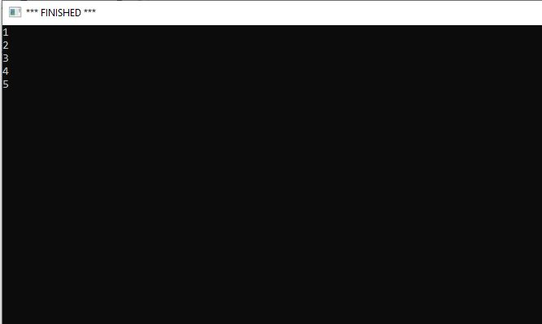

//A2 exotic canada

//A2.1

/*

void print_from(int a, int b){

if( a <= b ){

print(a);

new_line();

print_from(a + 5, b);

}

}

void main(){

print_from(10,90);

}

*/

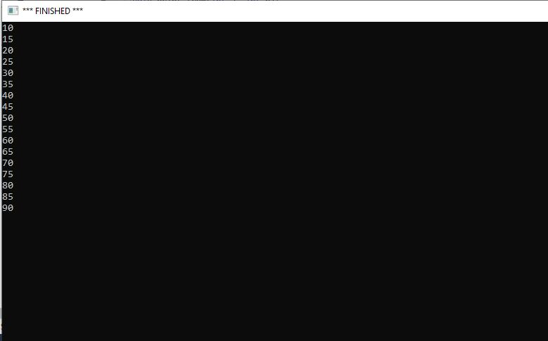

/*

//A2.2

// 1 mile = 1.609344km

void mph_kph(int x, int y){

if( x <= y ){

print(x);

int a = x * 1.609344;

print(" mph is ");

print(a);

print(".");

new_line();

mph_kph(x + 5, y);

}

}

void main(){

mph_kph(10,25);

}

*/

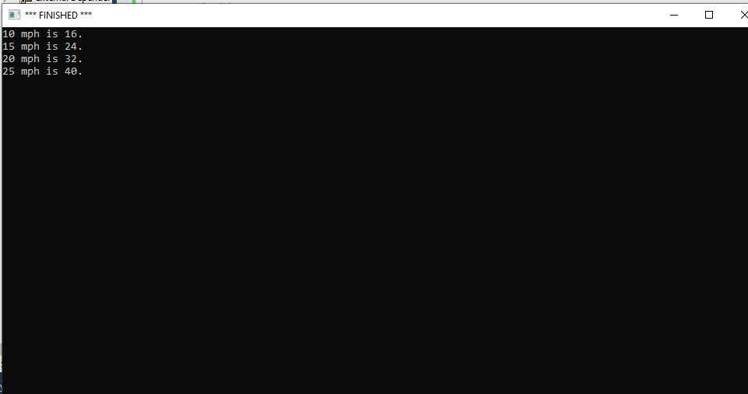

//A2.3 kmpl - us liquid gallons

//1 liguid gallon = 3.78541 L

// 1 mile = 1.609344km

//range 10 - 50 kmpl (increments of 5)

/*

void kmpl_conversion(int a, int b){

//a is kmpl

//output is mpg

if(a <= b){

print(a);

float x = (a*(1/1.609344)*(3.78541/1));

print(" kmpl is ");

print(x);

print(" mpg.");

new_line();

kmpl_conversion(a+5, b);

}

}

void main(){

kmpl_conversion(10, 50);

}

*/

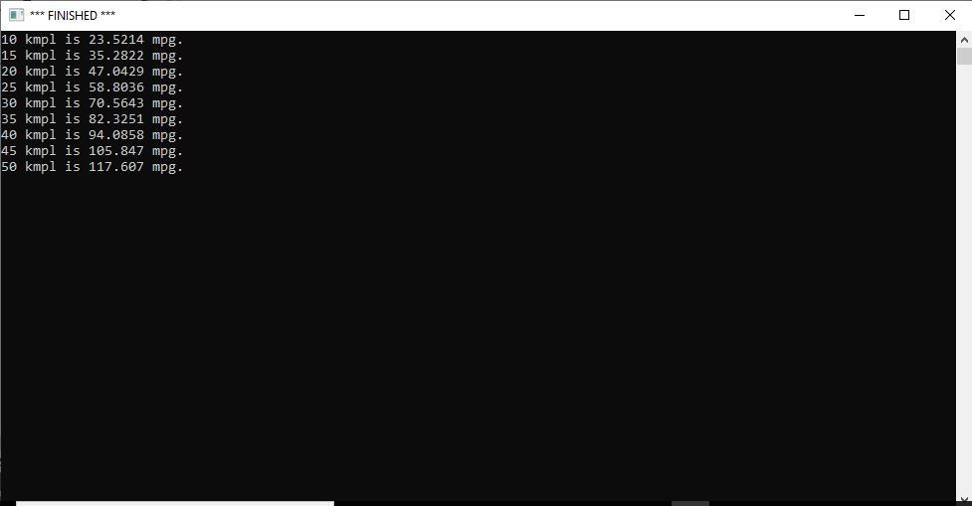

//A2.4a

//1USD = 1.23CAD

//Mean Fuel: 1.276 CA$ per liter

//2000 miles road trip, car fuel efficiency 28kmpl

/*

void print_km(int a){

if(a>0){

print(a);

}

}

void print_CA(int a){

if(a>0){

double b =((a/29)*1.276);

b = (int( b *100)/100.0);

print(b);

}

}

void print_mile(int a){

if(a>0){

double b =(a/1.609344);

b = (int( b *100)/100.0);

print(b);

}

}

void print_USD(int a){

if(a>0){

double b =((a/29)*1.276)/1.23;

b = (int( b *100)/100.0);

print(b);

}

}

void print_mpg(int a){

if(a>0){

double b = (a/1.609344)*1.352;

b = (int( b *100)/100.0);

print(b);

}

}

void road_trip_calc(int a){

print("If I am planning to take a ");

print_km(a);

print(" km road trip, in Canada, in a car with a fuel efficiency of 29.23kmpl, I need to spend ");

print_CA(a);

print(" CA$ for fuel. A ");

print_mile(a);

print(" mile road trip in Canada will cost me ");

print_USD(a);

print(" USD in a car with fuel efficiency of ");

print_mpg(a);

print(" mpg.");

new_line();

new_line();

}

void main(){

road_trip_calc(1000);

road_trip_calc(2000);

road_trip_calc(3000);

road_trip_calc(4000);

road_trip_calc(5000);

}

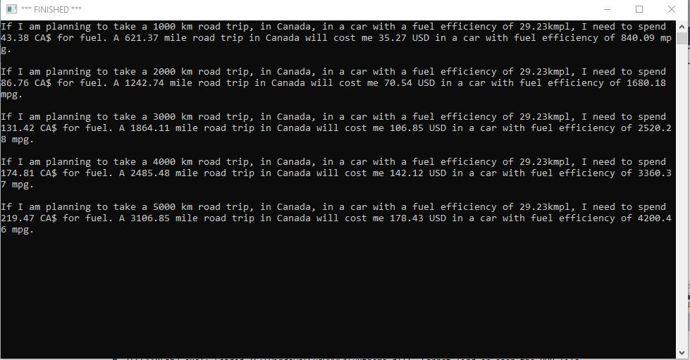

*/

//A2.2b

/*

void print_kmpl(int a){

if(a>0){

print(a);

}

}

void print_CA(int a){

if(a>0){

double b = ((5000/a)*1.276);

b = (int(b*100)/100.0);

print(b);

}

}

void print_mile(int a){

if(a>0){

double b = (a/1.609344);

b = (int(b*100)/100.0);

print(b);

}

}

void print_USD(int a){

if(a>0){

double b =((5000/a)*1.276)/1.23;

b = (int( b *100)/100.0);

print(b);

}

}

void print_mpg(int a){

if(a>0){

double b = (a/1.609344)*1.352;

b = (int( b *100)/100.0);

print(b);

}

}

void road_trip_calc(int a){

print("If I am planning to take a 5000km road trip, in Canada, in a car with a fuel efficiency of ");

print_kmpl(a);

print(" I need to spend ");

print_CA(a);

print(" CA$ for fuel. A ");

print_mile(a);

print(" mile road trip in Canada will cost me ");

print_USD(a);

print(" USD in a car with fuel efficiency of ");

print_mpg(a);

print(" mpg.");

new_line();

new_line();

}

void main(){

road_trip_calc(20);

road_trip_calc(25);

road_trip_calc(30);

road_trip_calc(35);

road_trip_calc(40);

}

*/

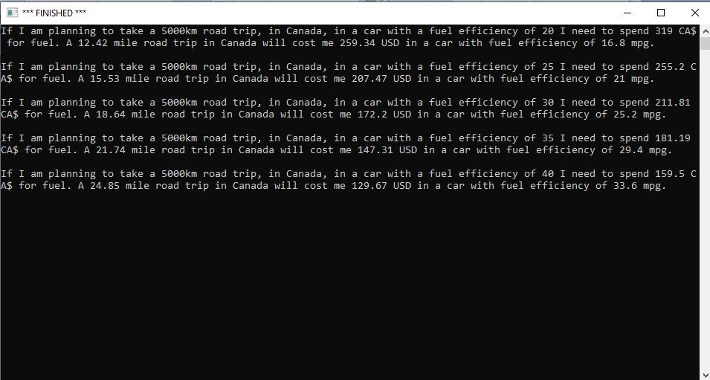

//B1

/*

void print_stars(int N){

if(N>0){

print("*");

print_stars(N-1);

}

}

void main(){

print_stars(7);

}

*/

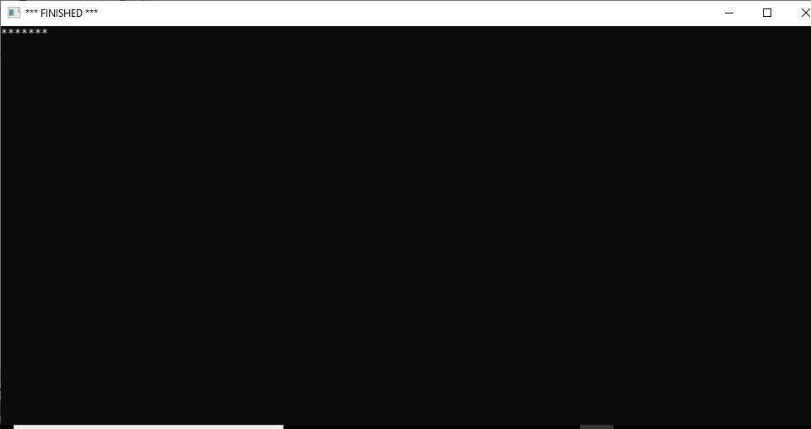

//B2

/*

void print_spaces(int N){

if(N>0){

print("_");

print_spaces(N-1);

}

}

void main(){

print_spaces(7);

}

*/

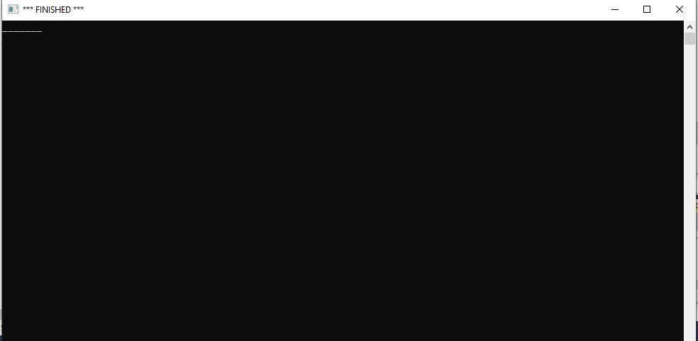

//B3

/*

void print_dots(int x){

if(x>0){

print(".");

print_dots(x-1);

}

}

void print_stars(int N){

if(N>0){

print("*");

print_stars(N-1);

}

}

void dotsstars(int A, int B){

if(A>0 && B>0){

print_dots(A);

print_stars(B);

}

}

void main(){

dotsstars(3,4);

}

*/

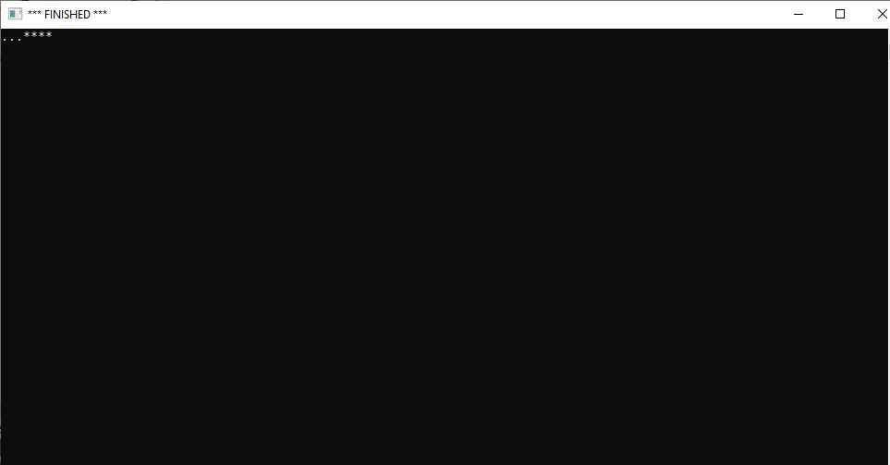

//B4

/*

void print_down(int const d){

if(d>0){

print(d);

}

}

void print_up(int const u){

if(u>0){

print(u);

}

}

void sequence(int const a, int const b){

if(a>0){

print_down(a);

print_up(b);

new_line();

sequence(a-1, b+1);

}

}

void main(){

sequence(5,1);

}

*/

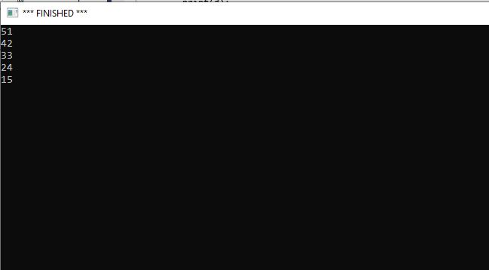

//B5

/*

void dots(int const dt){

if(dt>0){

print(".");

dots(dt-1);

}

}

void stars(int const st){

if(st>0){

print("*");

stars(st-1);

}

}

void triangle(int const a, int const b){

if(a>0){

stars(b);

dots(a);

new_line();

triangle(a-1, b+1);

}

}

void main(){

triangle(5,1);

}

*/

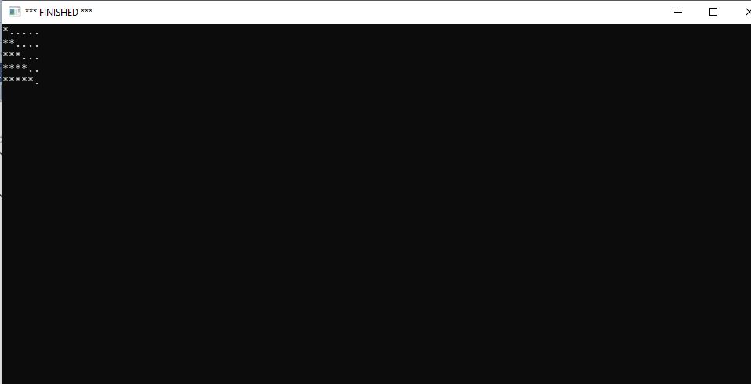

//C1

/*

double const pi = acos(-1.0);

void draw_circle(int d, int a){

turn_right_by_degrees(1);

//a = (2*pi*(d/2))/360;

draw_distance(a);

if(d<360){

draw_circle(d+1,a);

}

}

void main(){

make_window(500,500);

set_pen_width(5);

draw_circle(5,2);

}

*/

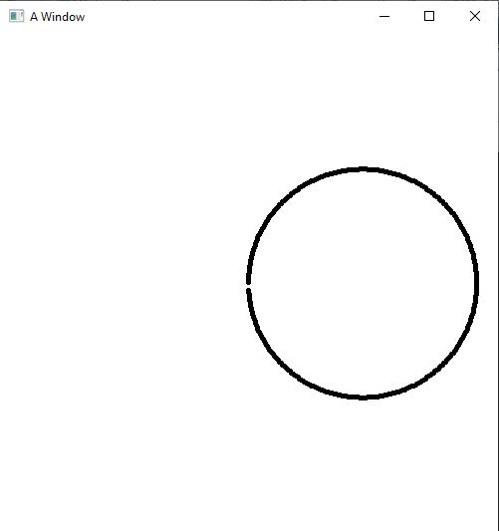

//C2 Part 1

/*

double const pi = acos(-1.0);

void draw_circle(int d, int a){

turn_right_by_degrees(1);

draw_distance(a);

if(d<360){

draw_circle(d+1,a);

}

}

void make_cannon(int x, int y, int a){

move_to(x-a*60,y);

draw_circle(0,a);

}

void make_cannon_body(int x, int y, int a){

move_to(x,y);

set_heading_degrees(0);

turn_right_by_degrees(a);

set_pen_color(color::white);

draw_distance(55);

set_pen_color(color::black);

draw_distance(245);

turn_left_by_degrees(88);

draw_distance(100);

turn_left_by_degrees(88);

draw_distance(380);

turn_left_by_degrees(90);

draw_distance(120);

turn_left_by_degrees(90);

draw_distance(22);

}

void main(){

make_window(2000,500);

set_pen_width(5);

make_cannon(150,400,1);

make_cannon_body(150,400,30);

}

*/

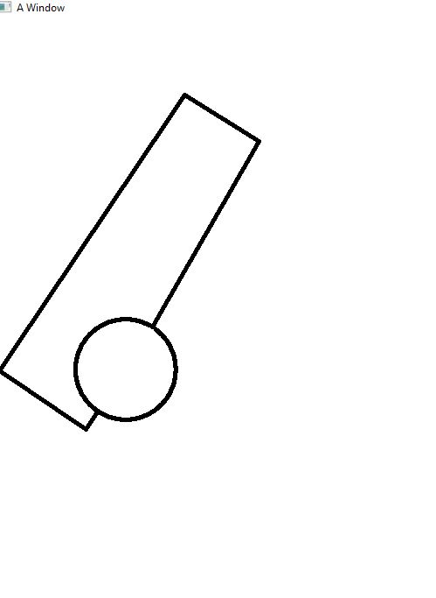

//C2 Part 2

/*

double const pi = acos(-1.0);

void draw_circle(int d, int a){

turn_right_by_degrees(1);

draw_distance(a);

if(d<360){

draw_circle(d+1,a);

}

}

void make_cannon(int x, int y, int a){

move_to(x-a*60,y);

draw_circle(0,a);

}

void make_cannon_body(int x, int y, int a){

move_to(x,y);

set_heading_degrees(0);

turn_right_by_degrees(a);

set_pen_color(color::white);

draw_distance(55);

set_pen_color(color::black);

draw_distance(245);

turn_left_by_degrees(88);

draw_distance(100);

turn_left_by_degrees(88);

draw_distance(380);

turn_left_by_degrees(90);

draw_distance(120);

turn_left_by_degrees(90);

draw_distance(22);

}

void main(){

make_window(2000,500);

set_pen_width(5);

make_cannon(150,400,1);

make_cannon_body(150,400,75);

}

*/

